7.71: The first condition, that the maximum height above the release point is h, is expressed as 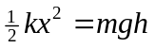. The magnitude of the acceleration is largest when the spring is compressed to a distance x; at this point the net upward force is 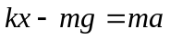, so the second condition is expressed as 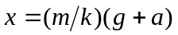. a) Substituting the second expression into the first gives
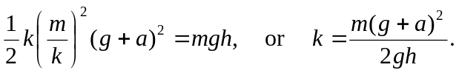

b) Substituting this into the expression for x gives 

